**Assignment 5.6**

**Problem Statement :**

Titanic Data Analysis

Write a mapreduce program to find the total number of people travelled in titanic.

**Program:**

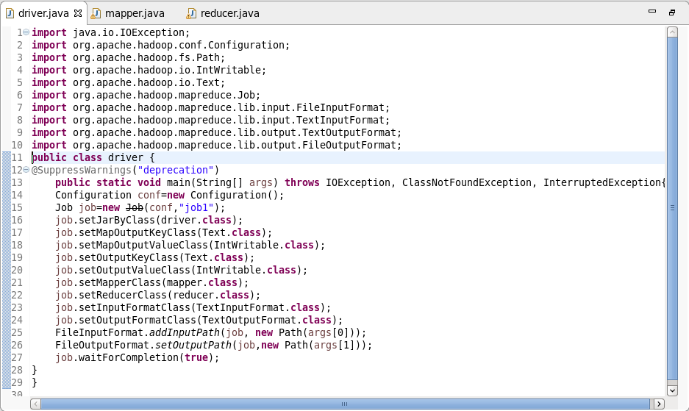

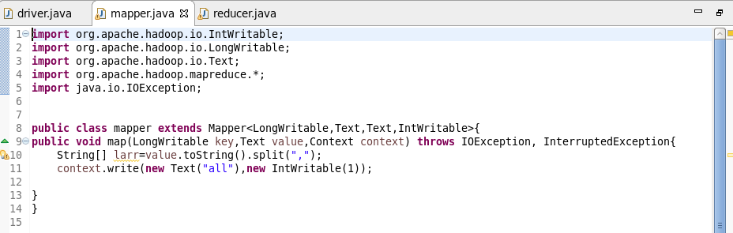

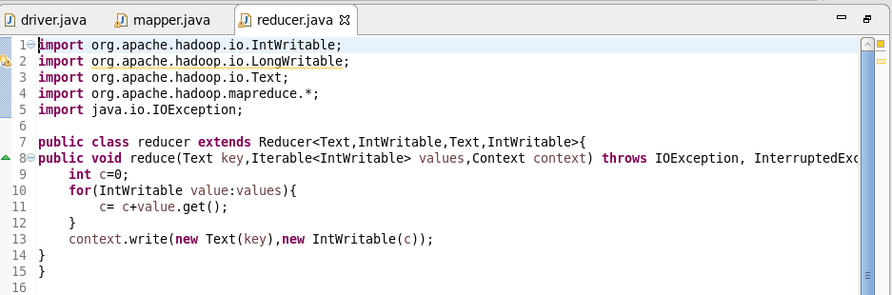

**Output:**

